**ITSP200 – Deliverable 2**

|  |  |
| --- | --- |
| **Group number and name** | Group 4 –The Poll makers |
| **Group member details** | J6H6SY5M7 – Jansen; Nadine (Leader)  RNWYMJ192 – Poole; Liam  P4PXK2T59 – Gumede; Luyanda  BXMDLL7W9 - Mtshatsheni; Nompumelelo |
| **Project title** | Advanced Polling System |
| **Submission date** | 14/05/2019 |
| **Signature of group leader** | N. Jansen |

**Contents**

Methodology 3

User requirements document 4

1 Introduction 4

1.1 Purpose 4

1.2 Scope 5

1.3 Definitions, acronyms and abbreviations 5

1.4 Overview 6

2. System requirements 6

2.1 System perspective 6

2.2 Functional requirements 6

2.1.1 A context diagram (high-level DFD) 8

2.1.2 An entity relationship diagram (ERD) 8

2.3 Non-functional requirements 9

2.4 Technical Requirements 10

2.5 User characteristics 10

2.6 Operational environment 10

3 Customer sign-off 11

References 12

# Methodology

The waterfall model; also known as the traditional approach which is also referred to as sequential development method which means that the previous phase has to be completed before the next phase can be started; as the name implies ‘waterfall’, once the water fell; it cannot be regained and only flows in one direction; the stages as of development is the same and cannot be returned to make changes.

The Waterfall model consists of 6 stages:

**Phase 1**:

Project initiation- this phase begins immediately after a problem is brought up and mentioned. This phase is used for the purpose of confirmation that there truly is a problem and to get justification for the project to be undergone and why it needs to be done. This phase is relatively very short compared to the other phases. This decision can be formulated by making use of technical, time and budget constraints

**Phase 2**:

Analysis- The analysis phase can only be started if the project initiation decision was acknowledged. This phase is used for data gathering; can be about the problem that there is and a solution thereof and this data is presented by means of a URD (User Requirements Document) or a Requirements Statement

**Phase 3**:

Design- This is where the system will be designed in detail, this where are the components of the systems and its interactions will be planned and how they will be done

**Phase 4**:

Development- This phase is when the system is being physically made and coded and its operating environment being prepared and purchased if non-existent. This phase also consists of reassessing the project validity and refining of the URD

**Phase 5**:

Implementation- The implementation phase is when the system is installed and where the end-users are trained to use the system

**Phase** **6**:

Review and closure/Maintenance- This phase is used to compared to the customer conducts an audit in which the final system is compared to the requirements statement which was drawn up in the previous phases. (S & Dr.M, 2012).



Figure1: Waterfall model (Joseph S, et al., 2015).

# User requirements document

# 1 Introduction

This is the URD that we have come up with and have put together. The URD contains the purpose, scope, overview, System perspective, Functional requirements, A context diagram (high-level DFD), An entity relationship diagram (ERD), Non-functional requirements, Technical requirements and User characteristics which details the system and the requirements needed by the customer which is that our group will be developing which is a voting system which allows voting to be done on campus for the SRC. Our URD contains the DFD which depicts the main processes that will be conducted by our system. The ERD will model the information we want to store in our system. The functional requirements will detail what our system will do and how. Our scope will detail the boundaries of our system, what our system will entail and also what won't be entailed. Our URD also contains a section that will provide an explanation of any unknown definitions so that these definitions or abbreviations can understood by the viewer.

## 1.1 Purpose

The purpose of the Voting application is to be able to hold free and fair elections. The app aims to hold SRC elections for the Claremont Pearson campus in a just and respectable manner. The app will eliminate students from voting more than once as this has been the case before. The application will save time when tallying up the votes because it will count as soon as the last vote has been casted so there will not be a waiting period for results.

## 1.2 Scope

The Advanced Polling System will take in login for the administrator and login for the students within the Pearson Institute of Higher Education (PIHE). The administrator will access the candidate details, approve operations and as well as deleting information within the system. The students will login as voters, the APS is designed with a user security access and will be responsible of determining the authenticity of any voter who has logged in, by his or her given unique student number and password. The student that will be on the record or registered as voter will only get a chance to vote once and not more than that. APS will be responsible for counting and generating the results of voters; hence it has the capability to produce the required results in regardless of the number of voters. The candidate details will be saved in the system and can be manually deleted by the admin. The system will show students the candidate details and from the point of voting and he/she can vote from all the candidate registered for the election and the system will produce a candidate number.

The Advanced Polling System (APS) is designed for student council voting at PIHE. The system will be used at PIHE and not any other colleges. The APS shall reduce the amount of time spend making long trains at the polling stations during voting. APS will produce less effort on running an intensive and expensive cost of paper trials. Rather the APS will run on a secure online voting system for the students at PIHE. It also helps increase the number of student’s voters within the school, as individuals will make it easier and more appropriate to vote for the chosen SRC rep.

## 1.3 Definitions, acronyms and abbreviations

* URD: User Requirements Document
* SRC: Student Representative Council
* PIHE: Pearson Institute of Higher Education
* APS: Advanced Polling System
* DFD: Data Flow Diagram
* ERD: Entity Relationship Diagram
* RAM: Random Access memory
* MB: Megabytes
* OS: Operating System
* SQL: Structured Query Language
* CPU: Central Processing Unit
* MAC: Media Access Control

## 1.4 Overview

* **System perspective:** This explains how the system relates to other systems
* **Functional requirements:** The functional requirements will be represented in a table format.
* **A context diagram:** A high level DFD diagram
* **An entity relationship diagram:** This is how the entities in the system would relate to each other.
* **Non-functional requirements:** This would be a list of all the non-functional requirements of the system.
* **Technical requirements:** This describes the technical requirements for the system, example the database application.
* **User characteristics:** This describes the user and how they would be working the system.
* **Operational environment:** This describes how the system will be operating.

# 2. System requirements

## 2.1 System perspective

The voting system will be an application that is a standalone. The application will not require any other applications to function because everything happens in the app itself.

## 2.2 Functional requirements

|  |  |  |  |  |
| --- | --- | --- | --- | --- |
| Functional Requirements | Unique Identifier | Source | Priority | Description |
| Registering as a candidate | R1 | Students | High | Potential candidates must be able to be registered onto the system. |
| Registering voters | R2 | Campus registration | High | All registered students on the campus must be able to vote. |
| Ensuring that voters only vote once | V1 | Application | High | For the elections to be fair all voters must only vote once. |
| Voters should only vote for 1 person at a time. | V2 | Application | Medium | Information about campus fees, rooms and shops. |
| Count votes fairly | D1 | Application | Medium | Votes must be counted fairly. |
| Feedback feature | F1 | Students | Medium | Voters will be able to make comments on what they thought of how the elections were held. |

## 2.1.1 A context diagram (high-level DFD)

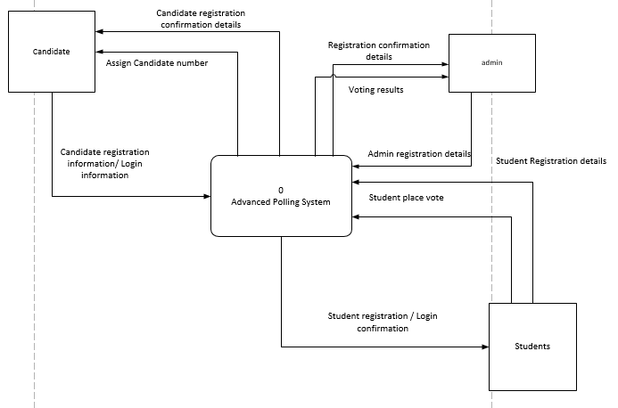

## 2.1.2 An entity relationship diagram (ERD)

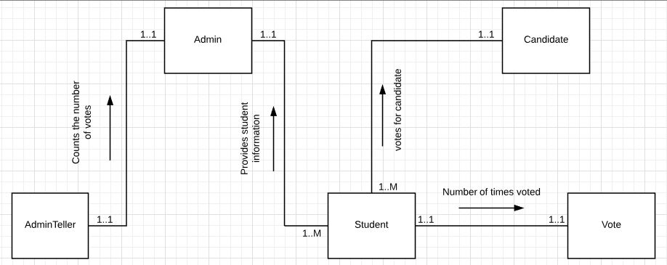

## 2.3 Non-functional requirements

1. **Human-Computer Interaction**

* User friendly; users will be students and administration and UI must be user friendly, easy to use and understand
* Be clear and easily visible

1. **Security**

* The system must be secure by making use of a unique user login detail
* The result of the APS should correspond to the votes cast list with best accuracy possible
* The APS should be able to recover crashes and to continue with the process
* It should be able to warn PIHE students of a failure of the system
* In regards of security issues, the APS should be able to shut down the entire system thus is to ensure that all connections to the server immediately to preserve already polled votes

1. **Availability**

* The system will be working issueless anytime when it is required for SRC elections
* It will only be accessed on campus’ pc’s which is always readily available
* The application should always launch and work when it is needed with no issues launching or responding

1. **Reliability**

* The system will be performing according to what is expected and 100% reliable
* The system should not crash for any simple reasons

1. **Communication Interface**

* The system has to communicate efficiently and quickly with the database created

1. **Hardware & software**

* At least 4GB of RAM so that the application can run without stutters. Slowdowns or freezes
* Keyboard for allowing user to input their login details
* Fast internet connection so that the application runs relatively fast
* Windows is the system OS because it is the easiest and is used by most people and will be available to almost everyone in comparison to MAC OS

## 2.4 Technical Requirements

* Programming Language: Java
* The system will run on Windows OS
* Database: Microsoft Access for creating tables, query / SQL
* Availability: The system will have higher availability during SRC elections
* Accessibility: The system can only be accessed by voters and admin at PIHE library PC’s
* Reliability: The system will be performing according to what will be expected

## 2.5 User characteristics

**Admin Users**

* Preferred language is English
* Tertiary educational levels
* Basic to tertiary technical skills
* Basic to tertiary computer skills

**Student Users**

* Preferred language is English
* Intermediate educational levels
* Elementary computer skills
* Elementary technical skills

## 2.6 Operational environment

* The system will run on the computers available in the library on campus.
* RAM: 128 MB
* Operating system: Windows Server 2008 Service Pack 1 and higher
* Processor: Intel Xeon CPU with 2.68Ghz.
* System type: 64-Bit OS

# 3 Customer sign-off

|  |  |
| --- | --- |
| **Customer name and surname** | **Customer signature** |
| **Group leader name and surname**  Nadine Jansen | **Group leader signature**  N. Jansen |

# References

Joseph S, V., Joey F, G. & Jeffery A, H., 2015. *Essentials of Systems Analysis and Design.* 6th ed. s.l.:Pearson Education Limited.

S, B. & Dr.M, S. M., 2012. *WATERFALLl Vs V-MODEL Vs AGILE: A COMPARATIVE STUDY ON SDLC.* [Online]   
Available at: http://jitbm.com/Volume2No1/waterfall.pdf  
[Accessed 2 May 2019].